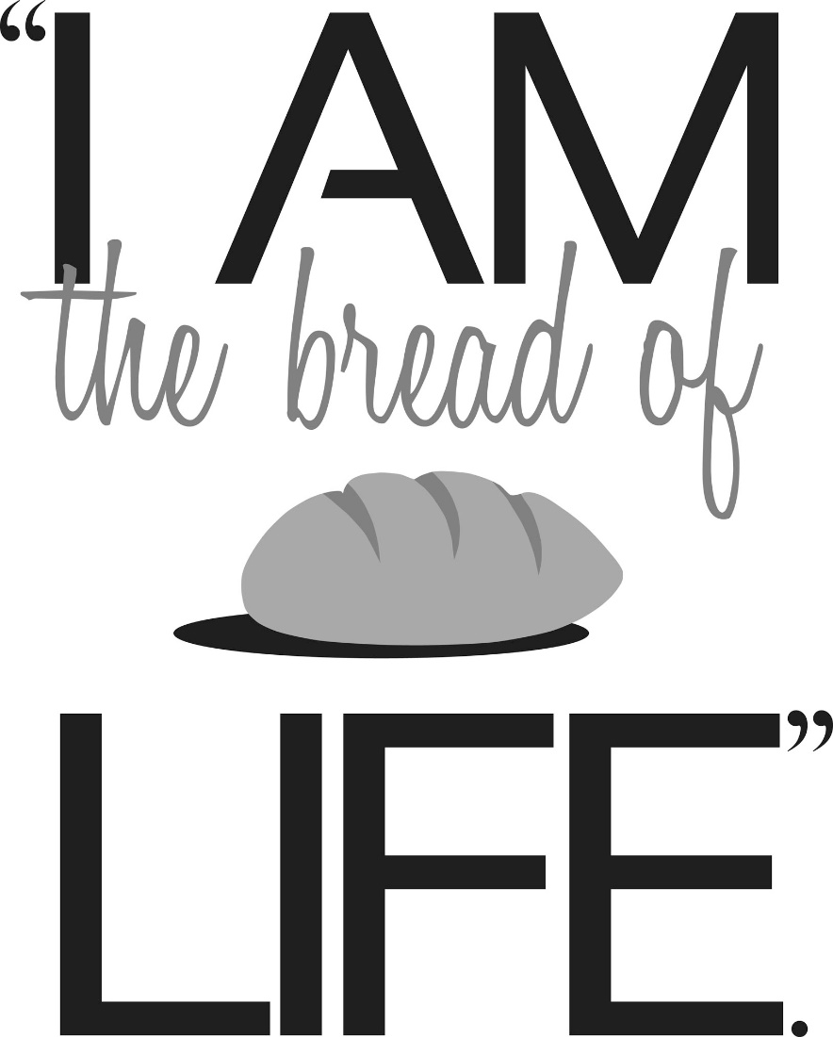

“Helping others receive grace, purpose and direction by proclaiming Christ’s love.”

17 East 27th Street
Scottsbluff, NE
(308) 632-8023
calvarylutheranscottsbluff.org

Midweek Lenten Services
6:30 p.m.

Psalm 51 Liturgy
written by Jay Beech

Centering Prayer: Lord God, you led your ancient people through the wilderness and brought them to the promised land. Guide now the people of your Church, that, as we journey through this time we call Lent, we may walk through the wilderness of this world toward the glory of the world to come; through your Son, Jesus Christ our Lord, who lives and reigns with you and the Holy Spirit, one God, now and forever. Amen.
(In preparation for our worship together, you are invited to take a moment of silence to offer your own prayers of worship and praise.)

Prelude Music

Welcome and Announcements

+WE LIFT OUR HEARTS IN WORSHIP+

*Opening Song: “Have Mercy on Me, O God” (Psalm 51:1-5)

Leader: I was brought forth in iniquity. Behold, in sin was I conceived.
Leader: (sings the verses)
Congregation: Refrain (above)

*A Lenten Litany

Blessed are you, O Lord, our God, king of the universe.
You bring forth bread from the earth.
Lord Jesus, you invite us this Lent to take up our cross and follow you.
You promise that in losing our lives we will find them.
Help us to journey with you to the cross.
Give us bread for our journey.
Jesus Christ is the bread of life; whoever eats of this bread will live forever.
We feast on you, O Lord. You have the words of eternal life. Amen.

Song: “Secret Heart” and “Song of Deliverance” (Psalm 51:6-14)

Leader:
Behold your desire: truth within the deepest part of me.
In my heart of hearts give me wisdom,
Wisdom in my secret heart; wisdom in my secret heart.

Scripture Reading

Message

Hymn Bread for the Journey
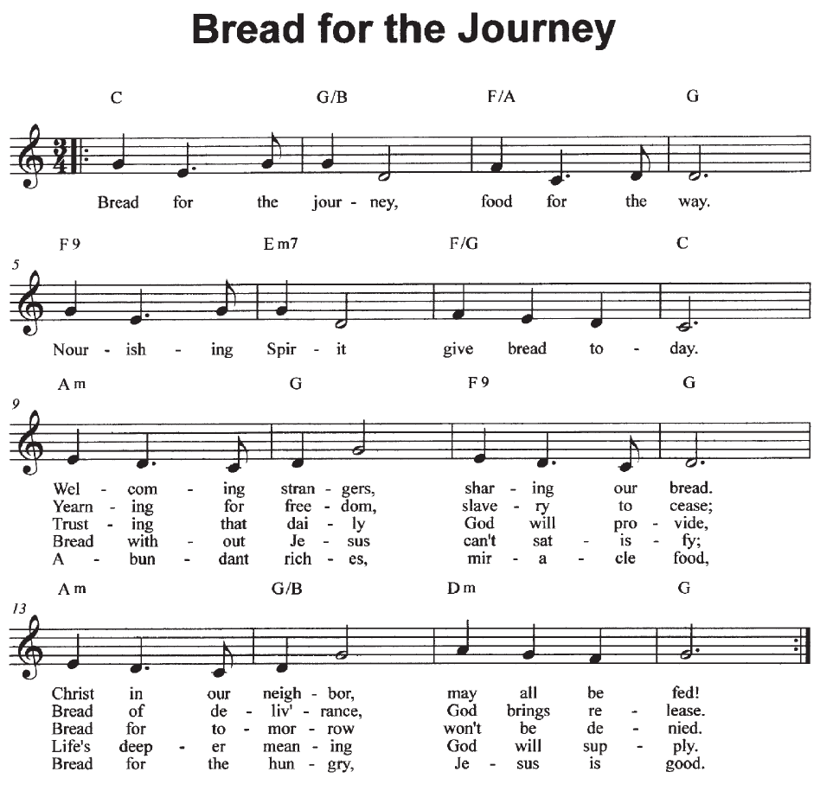

Prayers of the People

*The Lord’s Prayer

Our Father, who art in heaven, hallowed be thy name,
thy kingdom come, thy will be done, on earth as it is in heaven.
Give us this day our daily bread; and forgive us our trespasses,
as we forgive those who trespass against us;
and lead us not into temptation, but deliver us from evil.
For thine is the kingdom, and the power, and the glory,
forever, and ever. Amen.

Sending Song “The Sacrifice Acceptable” (Psalm 51:15-17)

Blessing for the Journey

May the love of God, which gives life to the world, sustain you. May the bread of life, Jesus Christ, feed you with the food that endures to eternal life. May the power of the Holy Spirit nourish and strengthen you in faith. Amen.

